

Practical Strategies for Gathering Web Application Requirements

William Waller

Version 2.1

Dec 14, 2000

Trademarks
Vignette, the V logo, Vignette.com, StoryServer, Vignette Syndication Server, VSS Relationship Management For The Connected Customer, Vignette Server Agent, Vignette Professional Services, VPS, and Vignette Village are trademarks or registered trademarks of Vignette Corporation in the United States and other countries. All other referenced marks are those of their respective owners.
Author: William Waller
Printed on 4/18/2000 11:02:00 AM
Contact Vignette: 901 South Mo Pac Expressway, Building III, Austin, TX, 78746 or 512-306-4300.

Table of Contents

Practical Strategies for Gathering Web Application Requirements 1
Sharing the Vision 1
Requirements 2
Business Requirements 2
Use Cases 4
Actors 5
Use Cases 5
Communicates Relationships 5
Extends Relationships 5
Uses Relationships 6
Eliciting Use Cases 6
Use Case Template 6
Functional Requirements 7
Non-functional Requirements 8
Appendix A. Use Case Template 9
Appendix B. Sample Use Case Diagram 10
Appendix C. References 11
Appendix D. Document Control 12

Practical Strategies for
Gathering Web Application Requirements

This white paper gives guidelines and techniques for determining the client’s requirements for a web application.

Sharing the Vision
Before a project team can expect to capture the breadth of a customer’s e-business application requirements, the team and the customer must share a clear and common vision. It is this common vision that subsequently drives the definition of each business requirement, and with which each use case and each functional requirement must align. Requirements that do not align with the business objectives of the web application should not be included. It is not enough for the team to be technically competent in deploying StoryServer sites. Each member of the project team must accept and understand the agreed-upon vision and be able to communicate it to others.
The vision must be developed and refined in iterative cycles. Simply asking the customer for the vision will not suffice. The team must continuously drill down to gain a clear understanding of the intent behind the objectives that the customer has presented. This iterative refinement process should encourage openness and brainstorming about the “perfect” project and how it relates to the business needs of the organization. A properly-defined vision will provide direction for the project.

Requirements
Typically requirements can be divided into four categories:
Business Requirements Usually represent the organizational requirements or the requirements imposed by the customer that influence the direction of the application. These requirements are often flushed out during the definition of the vision for the project.
Use Cases Use cases are one way of defining the user requirements. A use case is a description of the possible sequences of interaction between the e-business application and the external actors. Actors, therefore, are anything or anyone that interacts with the application.
Functional Requirements Represent the functionality that the developers must implement to achieve the common vision of the project.
Non-functional Requirements Requirements (other than functional requirements) that are imposed on the application such as performance requirements, architecture requirements, external interface requirements, and quality requirements.
How important is eliciting a complete and accurate set of requirements? According to a recent survey, the most significant reasons for project failure are the lack of user input, incomplete requirements definition, and the inability to manage changing requirements. Over 70% of projects either fail or are plagued with cost and time overruns. The vast majority of these failures can be avoided.

Business Requirements
Once the project team (which includes the customer and executive sponsor) has aligned with the clear and agreed-upon project vision, the business requirements will refine that vision into the scope of the e-business application. The scope draws boundaries and defines limitations.
Those who have a clear understanding of the customer’s business processes and those who comprehend the value that is provided by implementing the e-business solution should provide insight into business requirements. Generally, business requirements address opportunities, objectives, market, value added, and risks to the business. These areas are addressed in the major features, assumptions and dependencies, scope of initial and subsequent releases, user profiles and project priorities.
Last, and maybe most importantly for Vignette Corp., the team must accurately define web application success factors. These are, however, different than e-business success factors. Although it is not possible to ensure business success for the customer, we can implement a solution that meets or exceeds their expectations.
Keep in mind that the focus during this phase of the project is on the customer’s problem. Discussions should evolve around business initiatives, existing information, new hardware and technologies (such as WAP), support issues, education plans, and globalization.
Ultimately the business requirements definition process produces a domain diagram (sometimes referred to as a context diagram) that depicts the interactions between the web application and the external interfaces. See Figure 1. Domain Diagram for an example. It is this diagram that will be the precursor to the use case model, defining the external actors/interfaces to the system. The e-business solution is depicted as a circle with external interfaces represented as rectangles connecting to the solution. Arrows denote information flows to and from the external sources.
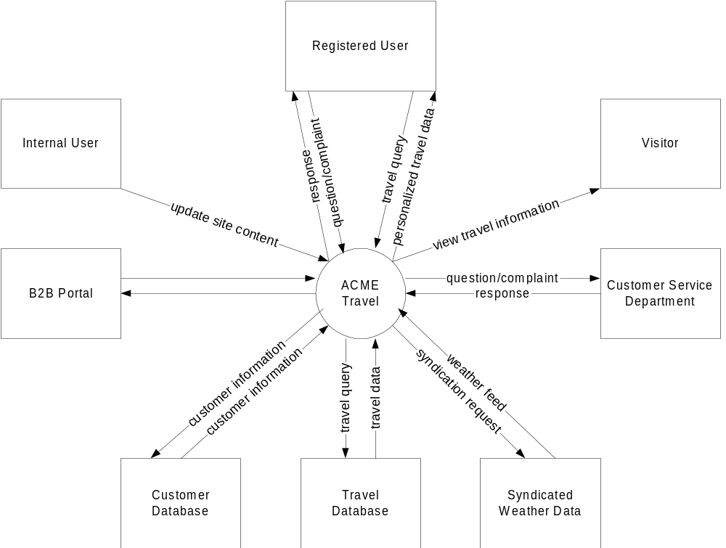
Figure 1. Domain Diagram

Use Cases
The next level of requirements definition is to describe all of the tasks the user community will need to perform with the web application and ensure that those tasks align with the business requirements. Use case scenarios describe a sequence of interactions between the user and the system that begins with a start stimulus, initiates a series of actions, and terminates when it is ready to begin the next stimulus. The use case instance exists as long as the transaction is operating. Thus a use case is a description of instances. The set of all use cases forms the use case model. Even though use case modeling is very prevalent in the object-oriented community, it can be applied to projects that follow any development approach. Use cases can be constructed using the following method.
Model behavior of uses cases that is reusable by the services it offers (uses)
Model
actors
Model
use cases
Model relationships between actors and use cases
(communicates)
Model exceptional or variant behavior of use cases (extends)

Figure 2. Use Case Construction

Actors
From the domain diagram (see Figure 1. Domain Diagram) modeled as part of the business requirements, you should have a good understanding of the external actors that integrate with your web application. The domain diagram is the archetypal, high-level view. In use case diagrams, you define typical usage scenarios at a much finer level of detail. Actors are denoted as stick person figures for human interactions (see Figure 3. Communicates Relationship) and as rectangles stereotyped with the <<actor>> label for external system interactions. Each actor icon defines a role and has a goal to achieve by interacting with the system.

Use Cases
In use case diagrams, use cases are denoted as ovals (see Figure 3. Communicates Relationship) and define units of functionality or behavior provided by the system. That is, a use case represents the services encapsulated within the system that are provided to the actors. Each use case must yield results to at least one actor involved in the scenario.

Communicates Relationships
The <<communicates>> relationship is the only permissible bond between an actor and a use case (see Figure 3. Communicates Relationship). An arrow on the relationship may be used to indicate behavior. An arrow pointing from the actor to the use case indicates that an actor initiates that use case. An arrow pointing from the use case to the actor indicates that the actor uses services provided by the use case. The <<communicates>> relationships may also be bi-directional (have an arrow on both ends) as in Figure 3. Communicates Relationship.

Figure 3. 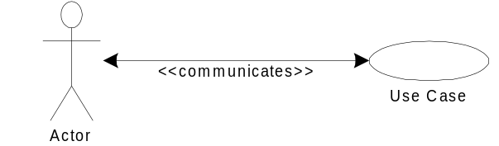Communicates Relationship

Extends Relationships
Variations of normal behavior may be captured through the <<extends>> relationships. These are generalizations between use cases in which a base use case instance may include the behavior specified by the extending use case. A condition must be defined in the base use case determining when the extended functionality will be used.
The arrow on the <<extends>> relationship always points to the base use case and the relationship is always stereotyped with <<extends>> (see Figure 4. Extends Relationship).
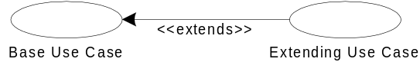
Figure 4. Extends Relationship

Uses Relationships
Another form of generalization between use cases is the <<uses>> relationship. To avoid duplication, functionality that is used by more than one use case is broken out into a separate use case and is included into the base use case. This functionality is similar to the calling of a subroutine. After the functionality of the subroutine, or included use case is completed, the calling routine or original use case continues. Just the opposite of the <<extends>>, the <<uses>> relationship always points from the base class to the common use case. Like the <<extends>>, the <<uses>> relationship must also be stereotyped.
Figure 5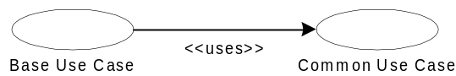. Uses Relationship

Eliciting Use Cases
Use cases represent user requirements and therefore are the best-gathered form representatives of the various user classes. Conduct workshops lasting two to three hours each with typical users to identify potential interactions with the application. Because many web applications have very diverse audiences, you may have surrogate users speak on behalf of typical users. Each workshop should include a facilitator, a scribe, at least one member from the user group, and at least one developer. The developer will act as the voice of reason, weeding out unrealistic requirements. Meeting attendees should prepare for the workshop by defining how their user class (defined in the domain diagram) may interact with the web application.
As the group reviews each use case, the facilitator should combine any redundant use cases and begin to prioritize each use case. Usually the most important use cases are discovered first which could be a good indication of priority. Each use case should be sketched and documented in a standard template format (see Appendix A). In subsequent sessions, the group should refine each use case until a common understanding is achieved.

Use Case Template
In order to get a better understanding of the interactions between the external interfaces and the system, it is beneficial (but not mandatory) to elaborate the use case in a written document. This documents useful information and encourages a more in-depth reflection on the process at hand. The template in Appendix A provides spaces for general information about each use case. It is used as a minimum guideline and, if necessary, can be modified to collect more project-specific information. The following are generally accepted attributes of a use case:
Use Case ID Each use case should be identified and tracked using a unique ID.
Actor Identify the actor who will benefit from the first use case.
Description Create a textual version of the use case scenario. For example, to view an online airfare quote, the description might read:
The site user specifies the origin and destination city or airport codes.
The web application can satisfy the request by requesting the quote information from the syndicated airfare server.
Preconditions Define any preconditions that must be satisfied to perform the use case, such as the stock airfare quote syndication server must be online.
Postconditions Describe the state of the system after the use case is completed.
Normal Course of Events List events that describe the sequence of actor actions and web application responses that would normally be expected to occur. This will ensure that each member of the team agrees upon the use case functionality.
Alternative Course of Events5 Define scenarios when the user has an option that will change the flow of the use case.
Exceptions Answer questions that will hinder the flow of the use case. For example:
What will happen if the syndication server is not available?
What will happen if the wrong airport code symbol is entered?

Functional Requirements
Business requirements and use case scenarios provide the vision of the project and a prospective from the external interfaces that will be interacting with it. Functional requirements use this information to explicitly define the behavior expected from the web application and the operations it performs. The requirements document consists of the assimilation of all of the functional requirements.
The requirements document, when signed off by the customer becomes a binding contract that is placed under change control. The requirements document is quite possibly the most important document that will be generated by the project team. It will provide the definitive guide for the functional specification, acceptance testing, quality assurance, and project planning. Changes to the requirements document must be approved by a change control board and approved by the customer. The steps within the change control process, such as evaluation, risk assessment, impact assessment, and priority are defined in the project plan (see the VSM Project Plan Template).

Non-functional Requirements
The requirements document should also include textual requirements statements of non-functional requirements. Non-functional requirements include design and implementation constraints, standards, regulations (including international), syndication, and third party integrations. Quality requirements are also considered non-functional requirements.
Appendix A. Use Case Template
Use Case ID:
Use Case Name:
Created by: |  | Last Updated by:
Date Created: |  | Date Last Updated:
Actor:
Description:
Preconditions:
Postconditions:
Priority:
Frequency of Use:
Normal Course:
Alternative Course:
Exceptions:
Includes/Extends:
Special Requirements:
Assumptions:
Notes and Issues:

Appendix B. Sample Use Case Diagram
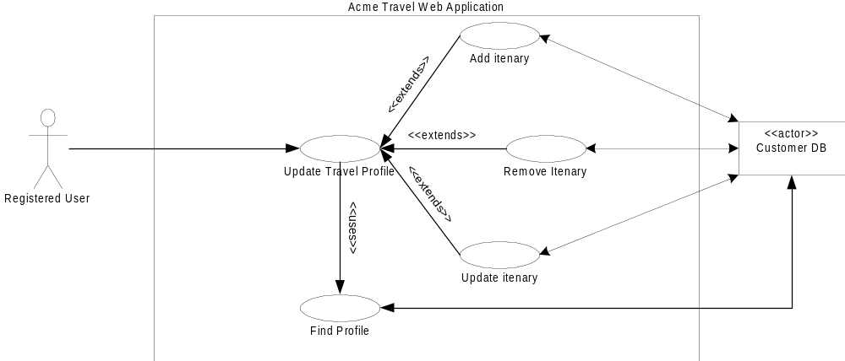
Appendix C. References
Supporting Documents
VSM Project Plan Template, March 30, 2000

Appendix D. Document Control
Document Revision History
Version | Release Date | Revised By | Revision Description
0.1 | 04/17/00 | William Waller | Created initial version of the document.
0.2 | 04/18/00 | Priya Hudson-DiTraglia | Edited and reformatted document.
0.3 | 04/19/00 | Priya Hudson-DiTraglia | Incorporated additional changes from the author.
1.0 | 05/12/00 | Priya Hudson-DiTraglia | Released
2. | 05/25/00 | Priya Hudson-DiTraglia | Added document abstract.
Document Storage
This document was created using Microsoft® Word 2000. The file is stored in ./VSM_GatheringWebAppRequirements
Document Owner
William Waller is responsible for developing and maintaining this document.

Standish Group, CHAOS
Exceeding a customers expectations does not include straying from the signed requirements specifications.
A Unified Modeling Language (UML) stereotype classifies a type of element using a string literal enclosed in double angle brackets
The system boundary can be denoted by a rectangle that encompasses the use cases and is labeled with the system name (see Appendix B. Sample Use Case Diagram).
The Normal and Alternative Course of Events should be formed as a series of Actor Actions and System Responses.
5

